# GLKLN V1.0

|  |  |
| --- | --- |
| **Description** | GLKLN V1.0. |
| **License** | [CC-BY-SA](https://creativecommons.org/licenses/by-sa/4.0/deed.en) |
| **Author** | Konstantin Gulitski |
| **Contributors** | NA |
| **Based-on** | NA |
| **Categories** | NA |
| **CAD Models** | [GitHub](https://github.com/Konstg16/GLKLN-V1.0) |
| **External Link** | [GitHub](https://github.com/Konstg16/GLKLN-V1.0) |

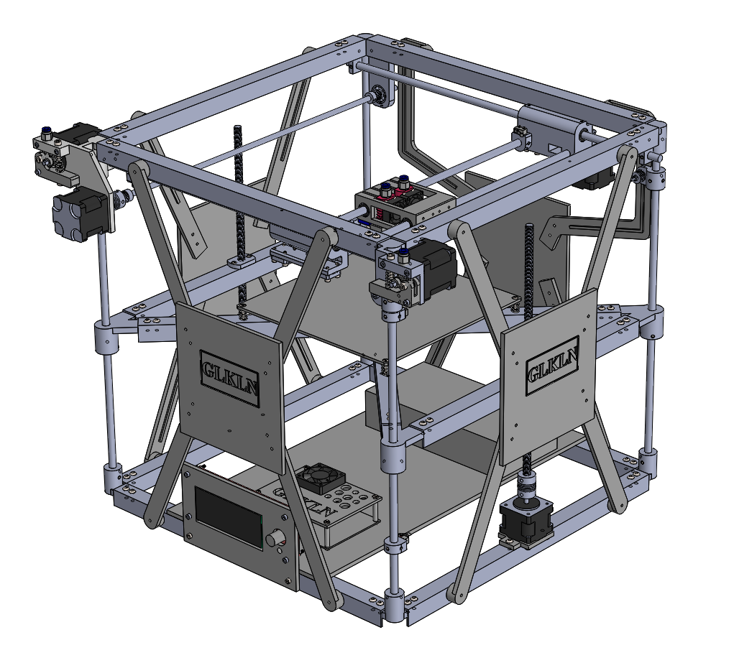

# License

This work is licensed under the Creative Commons Attribution-ShareAlike 4.0 International License. To view a copy of this license, visit http://creativecommons.org/licenses/by-sa/4.0/ or send a letter to Creative Commons, PO Box 1866, Mountain View, CA 94042, USA.

# Specification

|  |  |
| --- | --- |
|  |  |
| Working volume (max) | 240mm (X) x 290mm (Y) x 310mm (Z) |
| Working volume (nominal) | 220mm (X) x 220mm (Y) x 210mm (Z) |
| Working materials | PLA, ABS, others |
| Nominal Speed | 120mm/sec |
| Max Speed | 200 mm/s (depending on the object to be printed) |
| Filament | 1.75mm |
| Configuration | XYZ Cartesian drive using stepper motors |
| Computer interface | USB |
| Layer thickness | Adjustable 0.1mm, 0.2mm, 0.3mm, 0.4mm |
| Material handling | Two fixed material deposition extruders |
| Hotend nozzle size | 0.1mm, 0.2mm, 0.3mm, 0.4mm |
| Positioning accuracy | XY 0.1 mm |
| Motherboard | Makerbase MKS Gen L V1.0 |
| Power supply | 25A/12V DC, 300W |
| Firmware | Marlin |
| Host SW | Repetier-Host |
| Exterior dimensions | 528 mm wide x 541 mm deep x 433 mm high |
| Weight | about 18 Kg |
| Cost | < $300 (USD) |

# Main features/Improvements

1. Cubic construction – Strong and Stable
   * The cubic construction is still to be the most strong construction that provides the best quality at the cheaper cost.
2. Simple construction – The hotbed Z-axes are the part of the construction
   * Four vertical cornels of cubic construction are the Z-axes of the hotbed. It decreases the number of parts and cost.
3. The Hotbed can be increased – up to 240mm x 290mm
   * The nominal hotbed is 220mm x 220mm. You can upgrade up to 240mm x 290mm.
4. The Z-axis can be increased – up to 310mm
   * The nominal Z-axis has a 310 mm length. You can upgrade up to 350mm
5. The belt connection is simple and confident.
6. Almost all parts of construction made of plastic.

# Development

This is the first version that represents the nominal configuration. Several parts planned to be developed such as a cable holder, filament roller holders, ventilation system for hotends.

# History

NA

# Bill of Materials (BOM)

The updated version of the BOM can be downloaded from the project repository on the [GitHub](https://github.com/Konstg16/GLKLN-V1.0).

# Printed parts

Corner LU – Front Left Upper Corner: 1 pcs

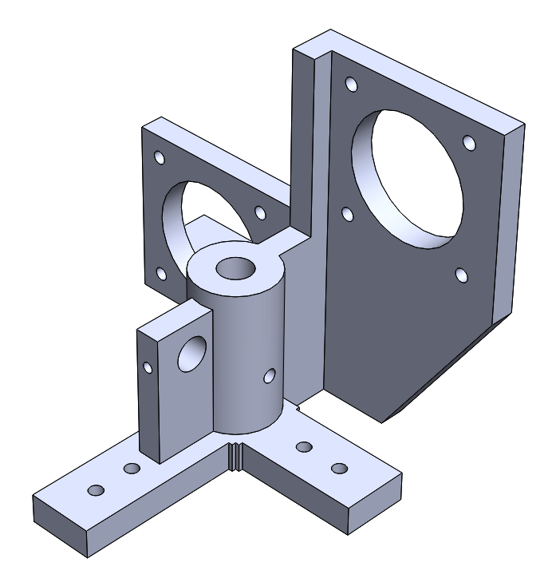

Corner LU B – Back Left Upper Corner – 1 pcs.

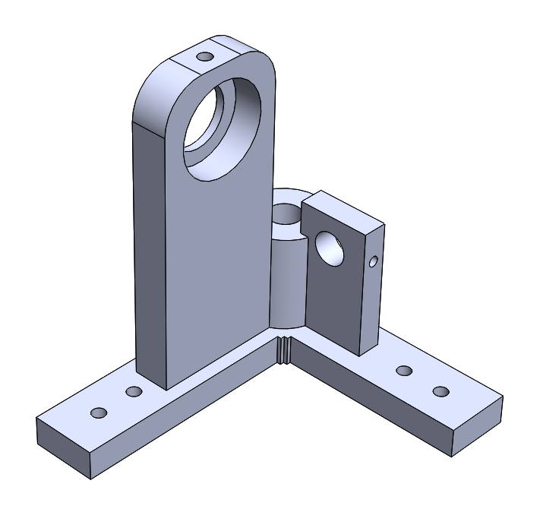

Corner RU F – Front Right Upper Corner: 1 pcs.

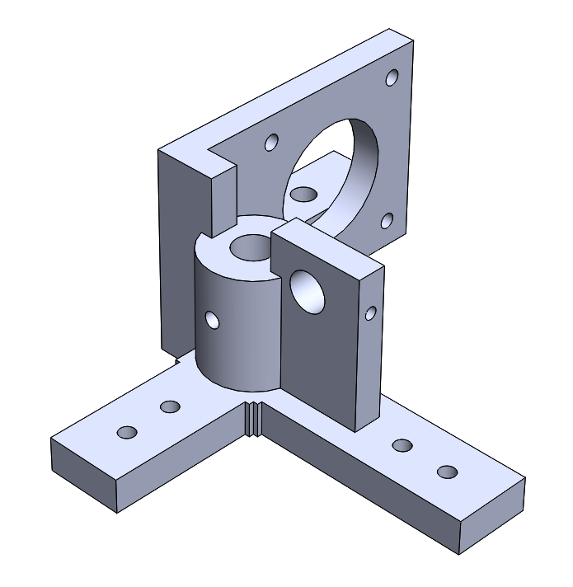

Corner RU B – Back Right Upper Corner: 1 pcs.

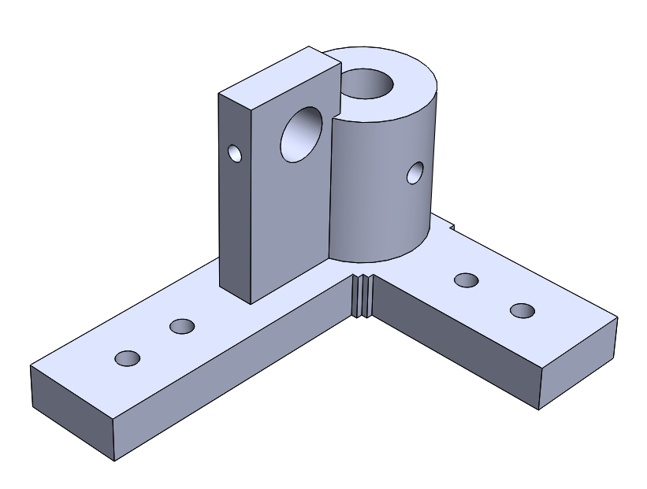

Corner L – Lower Corner: 4 pcs.

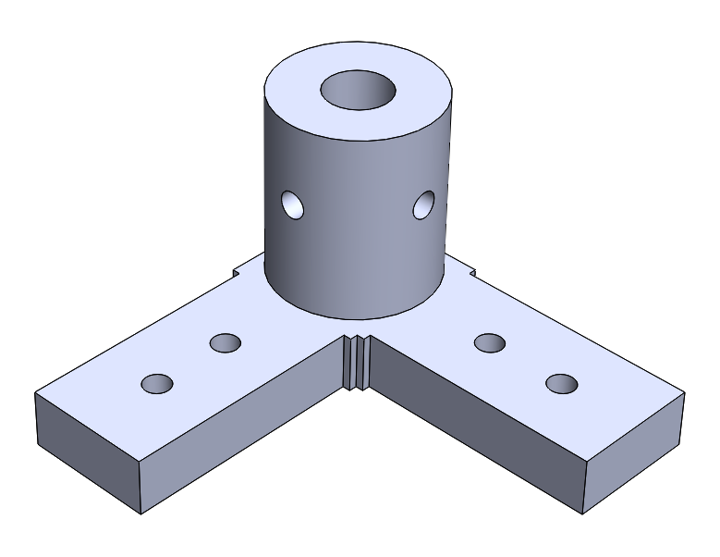

Corner B1 – Corners of the hotbed: 4 pcs.

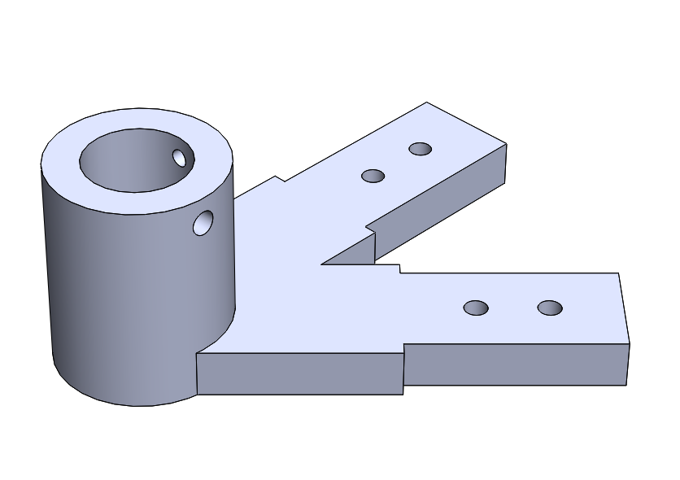

Cross – Hotbed cross 1 pcs.

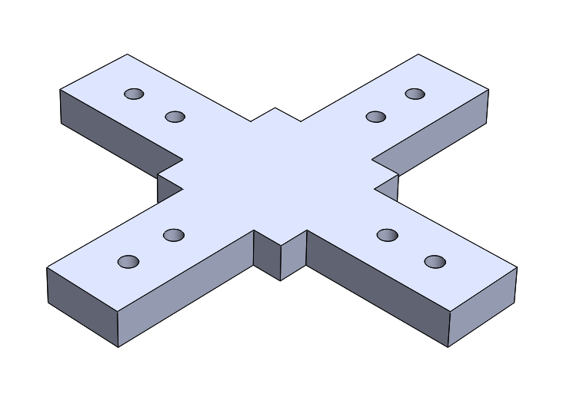

Wheel holder: The holder for X-axis timing wheels, 2pcs.

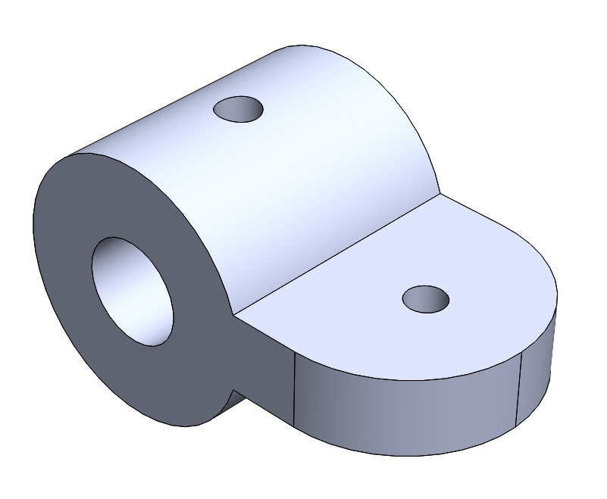

Motor Holder 1: The holder for Z-axis motors, 2pcs.

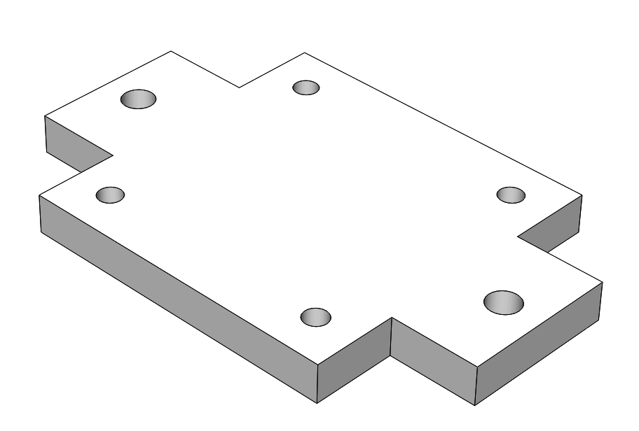

Front panel: The panel for Screen 2004, 1pcs.

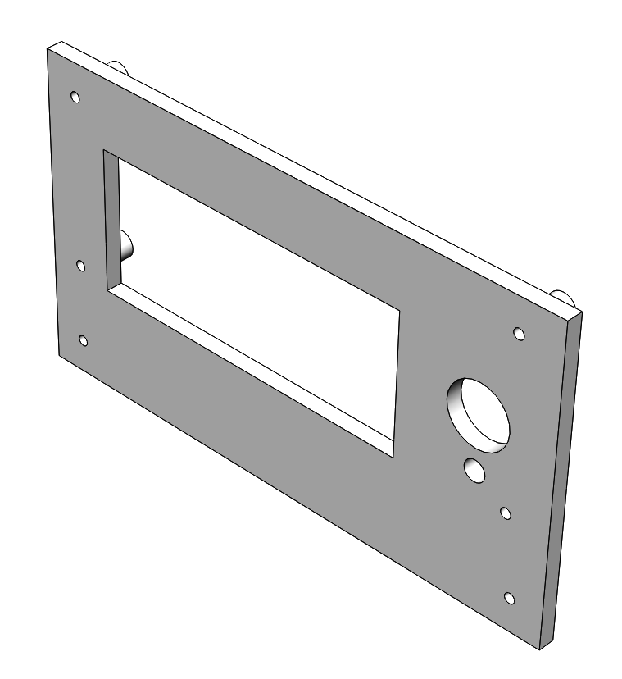

Front Train: The front carriage, 1pcs

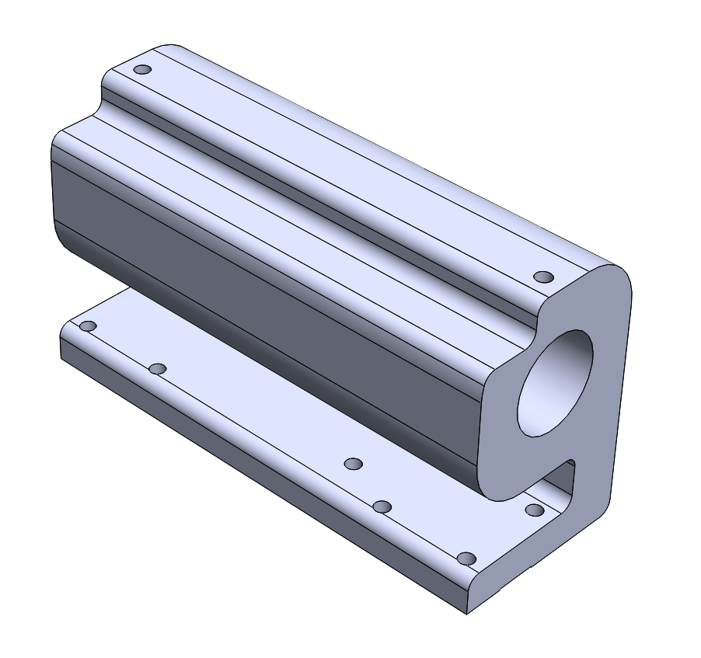

Extruder Flap: 1pcs

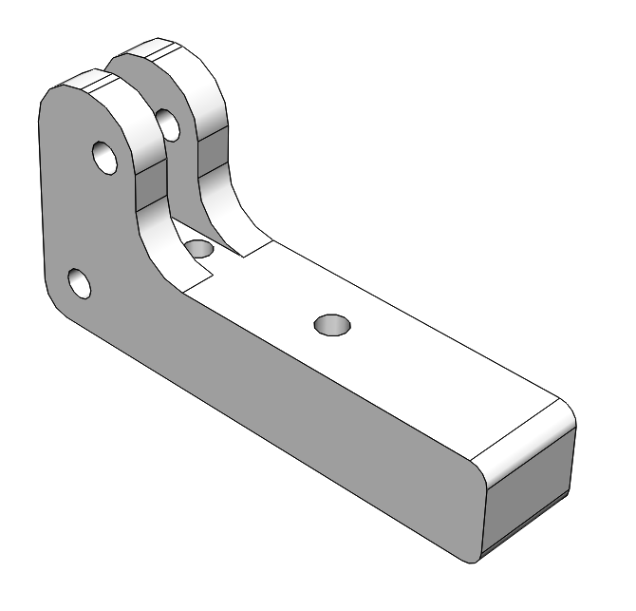

Cap MkB: The upper panel over MKB, 1pcs.

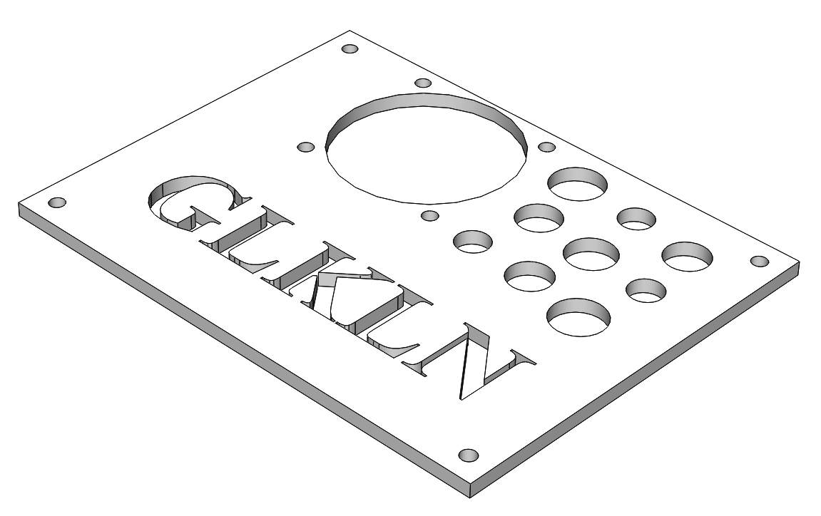

Back Train: The back carriage, 1pcs

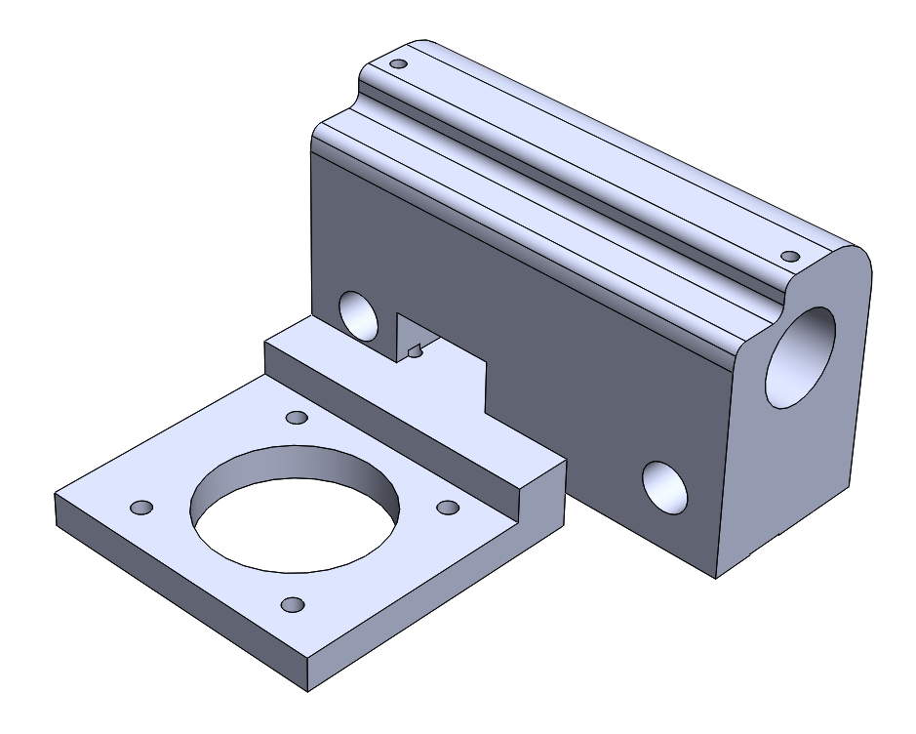

Y Train body: The carriage, 1pcs

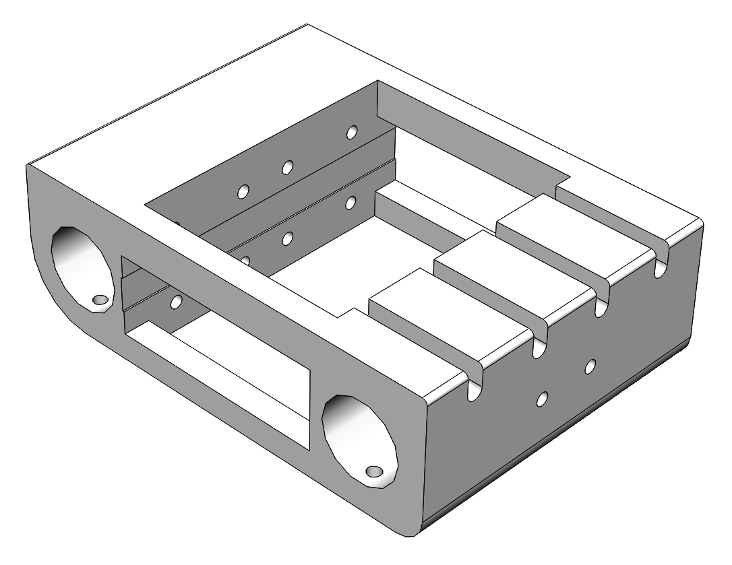

End Stop holder: 6pcs if you want to use two end-stop switches for each axis.

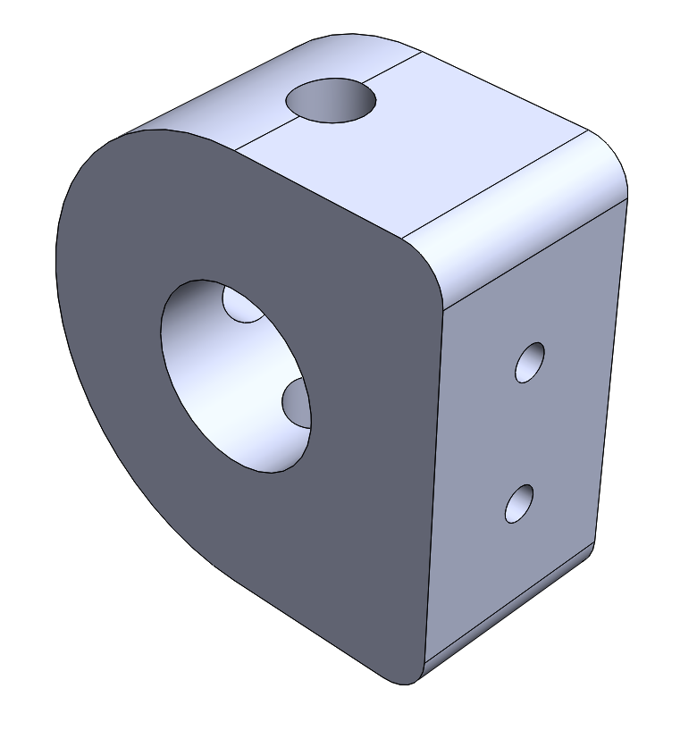

Timing belt holder: The holder required for fixing the timing belt end. 6pcs

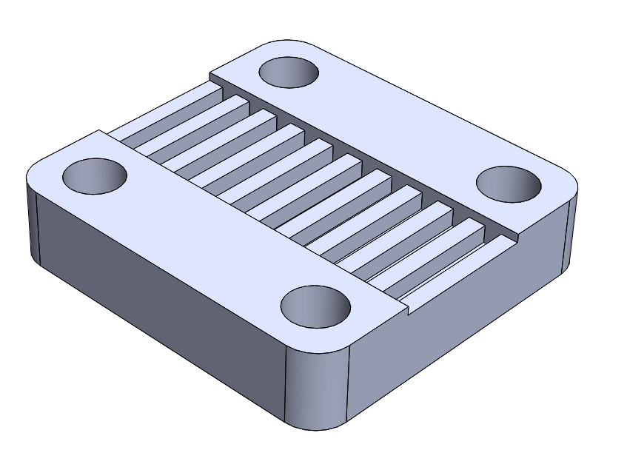

Base plate: finally produced from Fiberboard

Side panel: The panel for all four sides of the printer, 4pcs

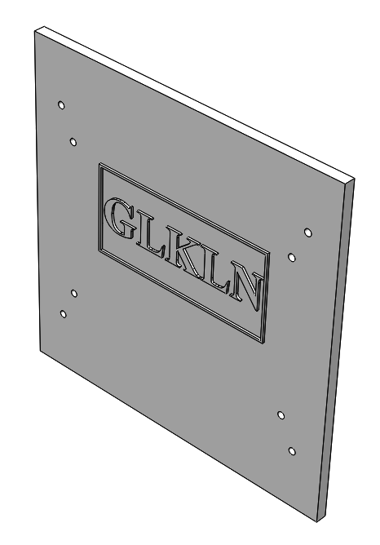

Side panel lead: The connector between the side panel and the profiles of upper and lower frames. 14pcs

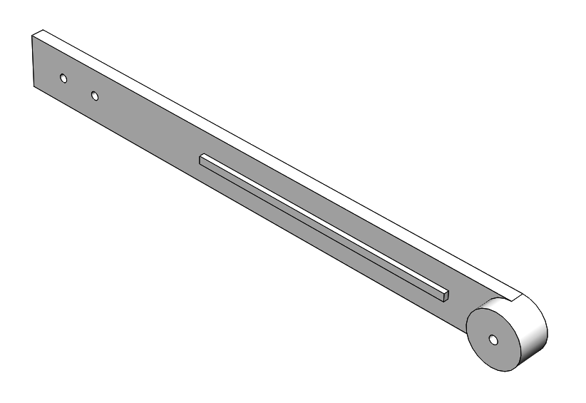 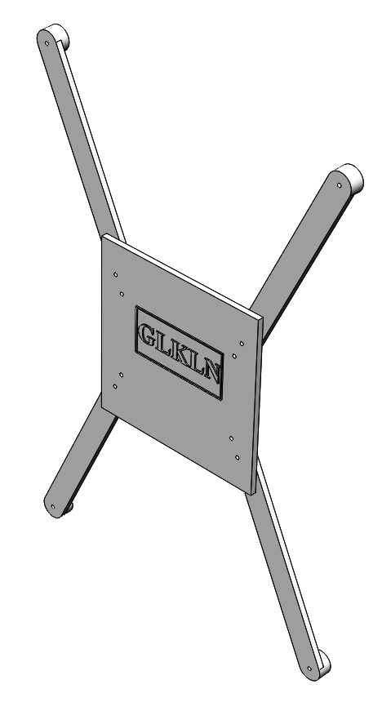

Side panel lead L: The connector between the backside panel and the upper frame profile at left. 1pcs

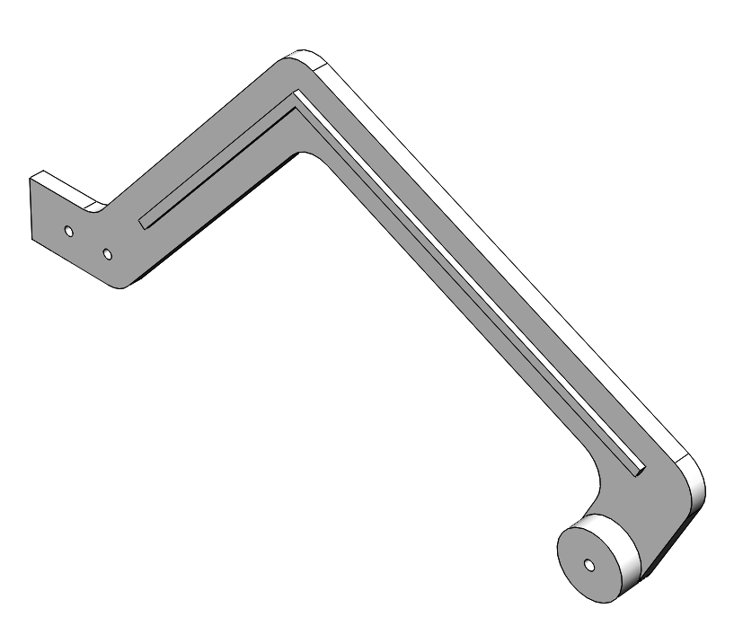

Side panel lead R: The connector between the backside panel and the upper frame profile at right. 1pcs

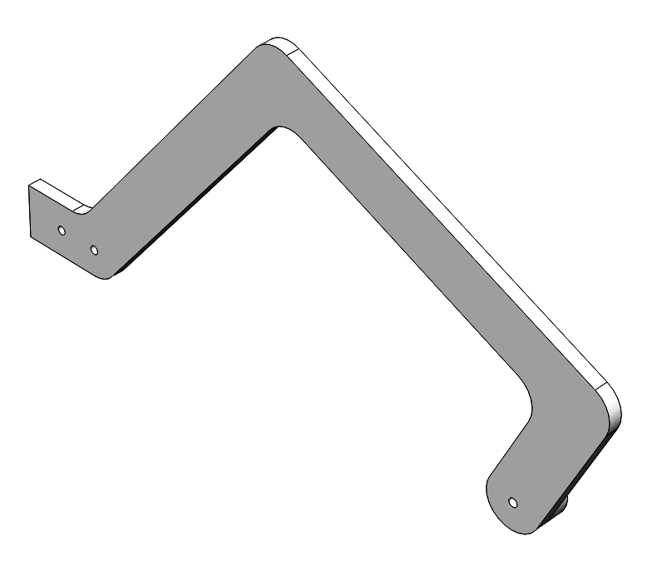 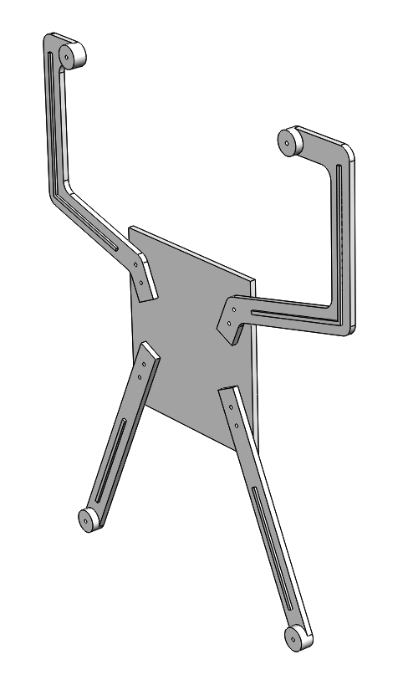

Power Supply Holder: The holder for power supply cable connector with fuse, 1pcs

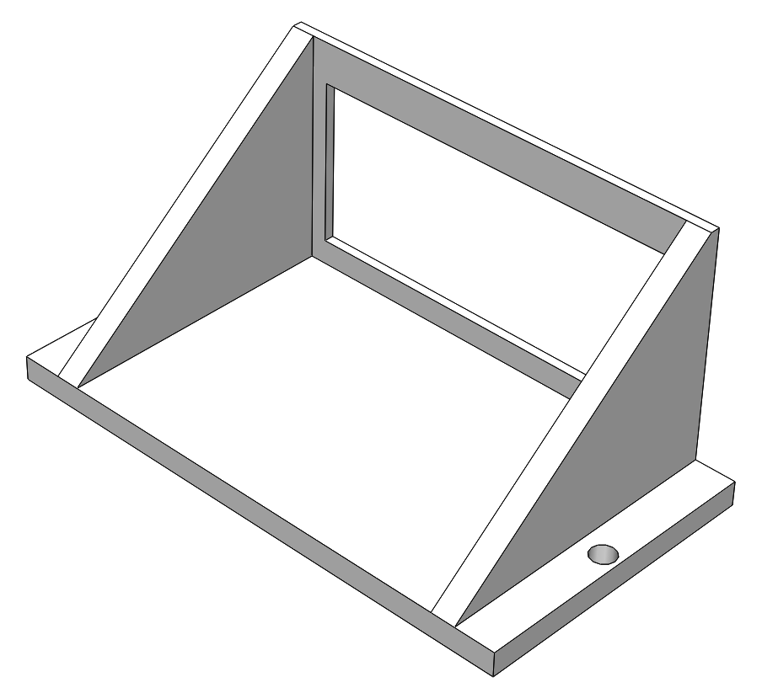

Power Supply Holder Cap: The cap of the holder for power supply cable connector with fuse, 1pcs

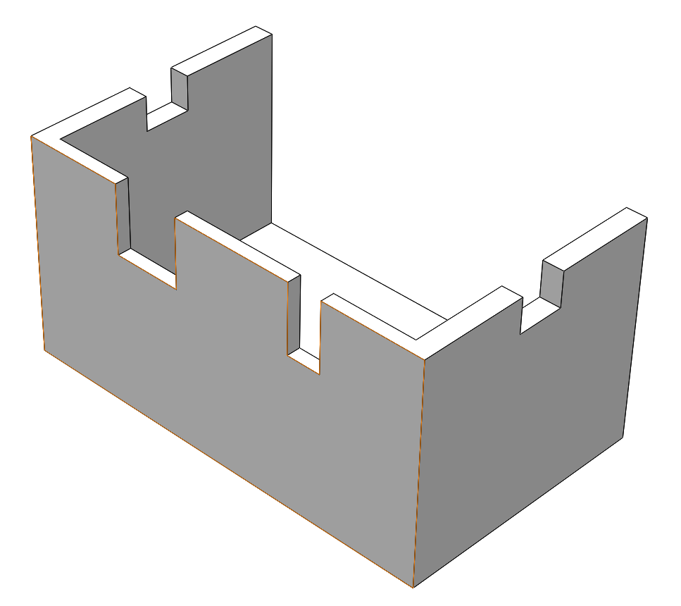

Extruder Holder: 1pcs

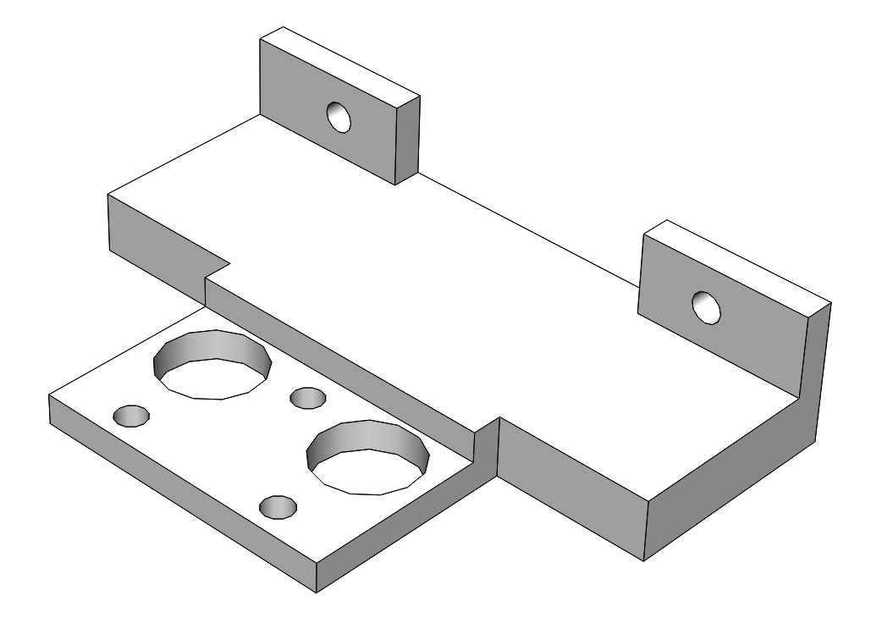

# Electronics

The printer is based on the [MKS-GEN L](https://github.com/makerbase-mks/MKS-GEN_L) motherboard.

# Software

The software is [Marlin-bugfix-1.1.x](http://marlinfw.org/) adjusted to the printer design. The updated SW version can be downloaded from the project repository on the [GitHub](https://github.com/Konstg16/GLKLN-V1.0).

# Order things to do

# Assembly sequence

## Tools required for the mechanical assembly mechanical

## Equipment needed for the electrical wiring

# Videos

# Notes